**Trip to India – Venue Analysis**

Table of Contents

❖ ***Introduction:*** 1

❖ ***Data requirements:*** 1

❖ ***Data Collection:*** 2

❖ ***Methodology:*** 2

❖ ***Data Preparation:*** 2

❖ ***Exploratory Data Analysis:*** 3

➢ ***Climate*** 3

➢ ***Hotel*** 4

➢ ***Transport*** 4

➢ ***Restaurants*** 5

➢ ***Other Venues:*** 7

❖ ***Result*** 7

❖ ***Discussion*** 8

❖ References: 8

* ***Introduction:***

Bob who lives in London, UK has got a month vacation in the month of December. He decided to go on a trip to India along with his family. But he is not sure which part of India he should visit this time. His friends suggested that southern state of India, with the coastal regions would match up to his expectations and can have lot more fun and experience Indian culture. His colleagues suggested that northern India surrounding Himalayan ranges would match his climate and trip can be very adventurous with hill trekking and bungee jumping. Now, he confused with which one to choose. Let us make explore about the Indian tour places in both Northern and southern India and let us give a road map to Bob to make his decision.

* ***Data requirements:***

Based on the interest, let us select 5 places each in northern and southern India as the neighborhood. As like everyone, for a trip, we would be looking for the below amenities in the selected neighborhood.

1. Climate
2. Hotel accommodation
3. Transport
4. Restaurants nearby the tourism spot

* ***Data Collection:***

We will be relying on the Foursquare data to get the nearby venues to analyze the Hotel, transportation details and restaurants nearby. And let us use the public data over the internet for analysis the Indian climate during the month of December.

* ***Methodology:***

We will use Foursquare data to get the most common nearby venue details and do some exploratory analysis. Later we will apply k-means clustering method to analyze the top 3 restaurants which are nearby the tourist locations.

* ***Data Preparation:***

As suggested earlier, based on Bob’s personal interest, let us select 5 places in northern and southern part of India each. And for us to analyze further, we get us get the latitude and longitude co-ordinates [we these data is not readily available over the internet we have used excel file] and our interested data details is as follows

|  |  |  |  |  |  |
| --- | --- | --- | --- | --- | --- |
| **Place** | **Location** | **State** | **Category** | **Latitude** | **Longitude** |
| Alapuzha | South | Kerala | Backwater | 9.5013 | 76.33232 |
| Munnar | South | Kerala | Hills | 10.08187 | 77.06294 |
| Athirapalli | South | Kerala | Falls | 10.2851 | 76.5697 |
| Mahabalipuram | South | TamilNadu | Architecture | 12.62693 | 80.19271 |
| Mysore Palace | South | Karnataka | Palace | 12.29581 | 76.63938 |
| Tirumala | South | Andha | Temple | 13.63551 | 79.41989 |
| Leh & Ladakh | North | Jammu&Kashmir | Mountain | 34.14473 | 77.55612 |
| Darjeeling | North | West Bengal | Hill | 27.03941 | 88.26387 |
| Rishikesh | North | Dehradun | Bungee jumping | 30.08639 | 78.26658 |
| Kasi(Ganges) | North | West Bengal | River | 25.31765 | 82.97391 |
| Taj Mahal | North | Delhi | Site | 27.17389 | 78.04207 |

* ***Exploratory Data Analysis:***

Let us first see what are the places that we are interested in using the Folium map generator

.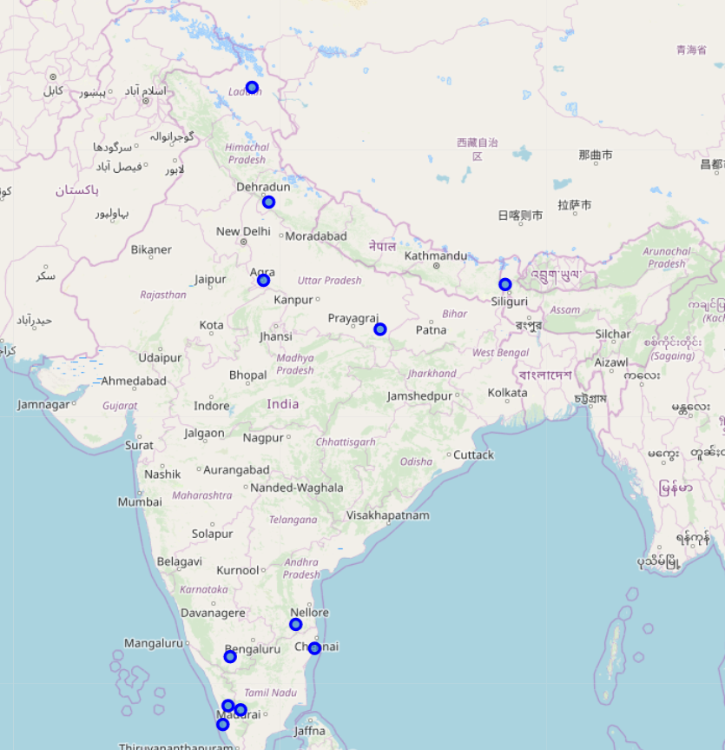

Now using Foursquare API, lets us get the top 100 venues nearby in the 10km radius of our interested tour attraction sites. Based on the result of our query, we will analyze venues surrounding each neighborhood and get more details about each place’s hotel, transportation amenities and Restaurants.

* + ***Climate***

While travelling from United Nations to a tropical country, climate is the first thing that everyone could think of. Data trend about Indian climate is not available for free unfortunately for us to analyze. However simple google search returned average climate trends on the past few years. The climate of our interested places is as follows

|  |  |  |  |  |  |  |  |  |  |  |  |  |  |
| --- | --- | --- | --- | --- | --- | --- | --- | --- | --- | --- | --- | --- | --- |
| Average Temperature | Winter (Dec – Feb) | | | Summer (Mar – May) | | | Monsoon (Jun – Sep) | | | Post-monsoon (Oct – Nov) | | | Year-round |
| City | Min | Avg | Max | Min | Avg | Max | Min | Avg | Max | Min | Avg | Max | Avg |
| [Thiruvananthapuram](https://en.wikipedia.org/wiki/Thiruvananthapuram) | 23 | 26 | 29 | 24 | 27 | 30 | 24 | 26 | 28 | 23 | 29 | 23 | 26 |
| [Bangalore](https://en.wikipedia.org/wiki/Bangalore) | 15 | 22 | 28 | 21 | 27 | 34 | 20 | 24 | 28 | 19 | 23 | 28 | 24 |
| [Shimla](https://en.wikipedia.org/wiki/Shimla) | 1 | 5 | 9 | 10 | 14 | 18 | 15 | 18 | 20 | 7 | 10 | 13 | 13 |
| [Leh](https://en.wikipedia.org/wiki/Leh) | −13 | −6 | 0 | −1 | 6 | 12 | 10 | 16 | 24 | −7 | 0 | 7 | 6 |

Leh and Shimla is the Himalayan ranges which has similar climate like UK. Whereas Thiruvanthapuram and Banglore are southern part experience mid dry and wet climate. But it can be bearable and not too high. Let us do further more analysis on the other aspects.

***Hotel***

Upon comparison we see that northern tourist attractions have a greater number of hotels and gives us more choices to choose from (see Taj Mahal is having 15 hotels nearby). Also, one place (Darjeeling) has no hotels at all.

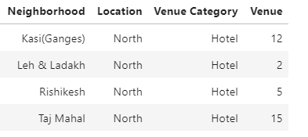

On the other hand, we see that south India attractions has at least one hotel to stay.

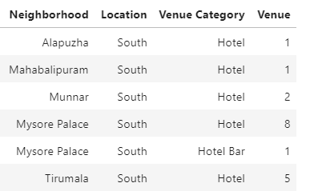

***Transport***

While analyzing the mode of transport (we have considered public access airport/train station/ bus station in the nearby venues), its sad that there are few places which does not have any public places. And there are places which has both airport and train station. The detailed chart distinguishing the north and south is as follows

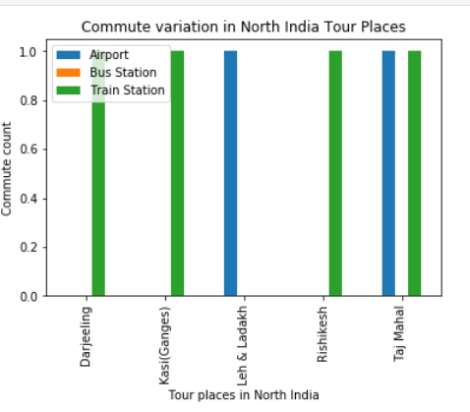

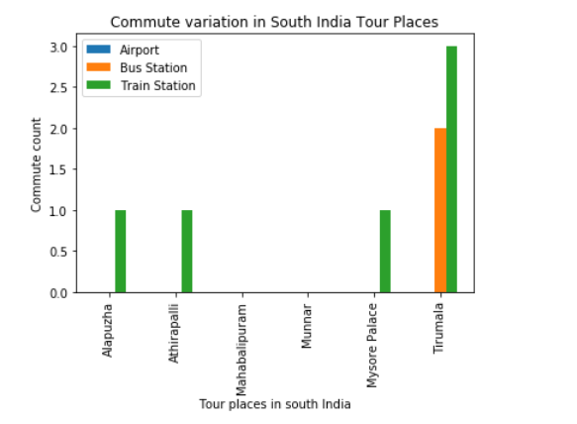

From the graph it clear that north India has good transport options than south part. However, with many on taxi services now, transport factor is still not a strong hold to decide on.

***Restaurants***

When it comes to restaurant, we have too many options. We have the home style Indian restaurants as well as multi-cuisine in all the places (After all India is known for its hospitality!).

Lets see what the top 3 types of cuisines in each places!!.

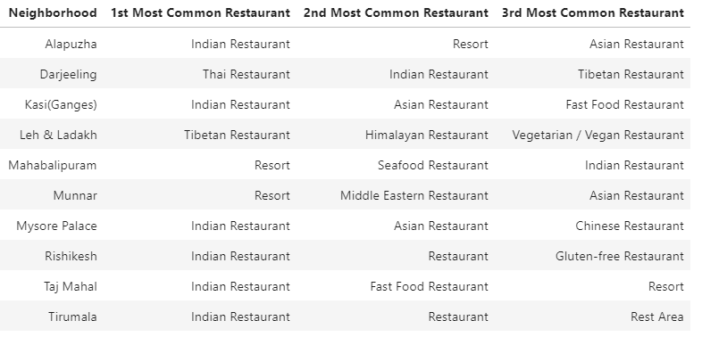

For a quick check, let us cluster the tour places and see which are the MUST see places among the other 4 places (Red color represents the top, Blue to the second and green to the last)

South India:

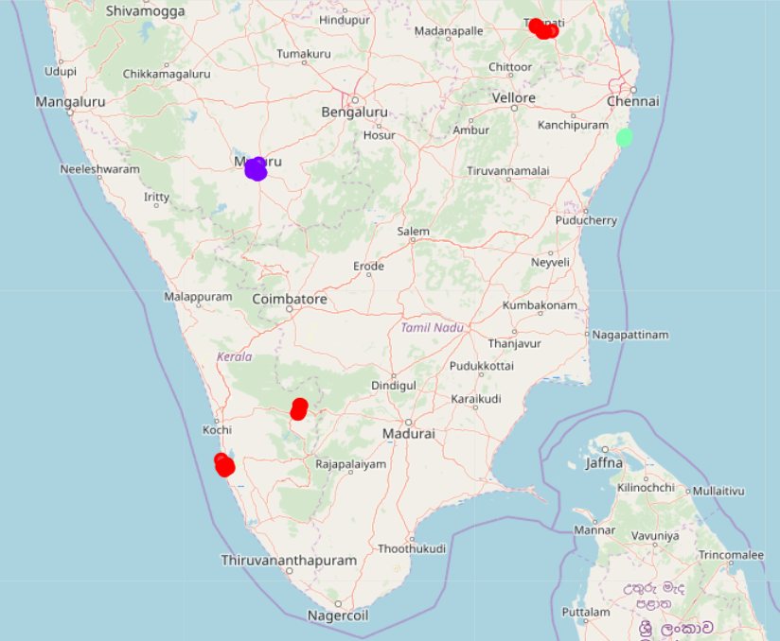

North India:

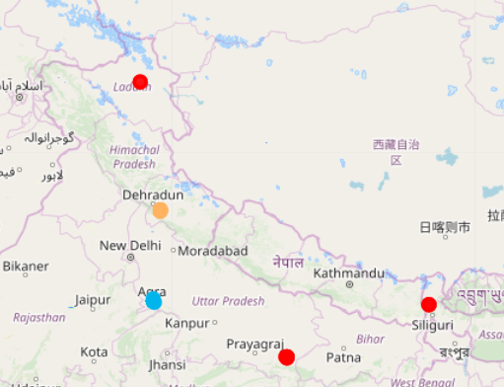

***Other Venues:***

Let us also see if there are any other interesting find in our venue details. And yes, it does! We have lighthouse, beaches and historic museum. So, all the places our interest definitely has good spots to enjoy 😊

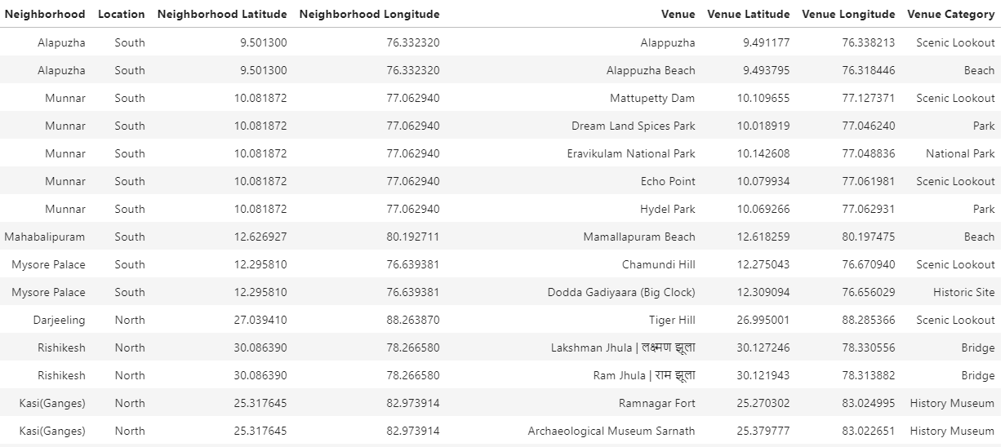

* ***Result***

As per the outcome, all the selected places have the basic amenities and good venues to have a memorable thing. The only thing that differs much is the CLIMATE of Southern Indian and northern India. People from UK could choose Southern India to enjoy its culture rather than at similar climate. People to be romantic could choose the world wonder Taj Mahal. Its definitely the personal choice since both southern and northern parts of India has its own advantages and disadvantages.

* ***Discussion***

The result is purely based on the selected places of one’s interest. There are many other tourist places in India which might need to considered. Other opinion on the above observation is welcome.

* References:

Climate : <https://en.wikipedia.org/wiki/Climate_of_India>

India Tour sites: <https://www.keralatourism.org/destination/waterfalls/>